Tony Evers, Governor
Preston D. Cole, Secretary
Telephone 608-266-2621
Toll Free 1-888-936-7463
TTY Access via relay - 711

State of Wisconsin
DEPARTMENT OF NATURAL RESOURCES
101 S. Webster Street
Box 7921
Madison WI 53707-7921
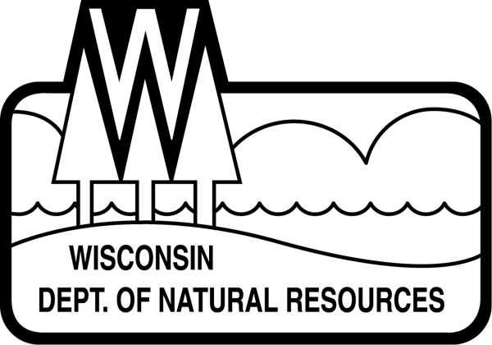
February 8, 2022

Name
Address
City State Zip Code

Name:

The Department of Natural Resources (Department) is planning a timber sale on state-owned land that borders your property in Name County. The Department has placed a blue paint line for the purposes of establishing the timber sale boundary. This is not a legal survey of the property line.

The timber sale boundary was established using surveyed corners, county parcel data, and a handheld Global Positioning System (GPS). The established blue paint line is a close and reasonable approximation of the actual property boundaries but is not a legal survey of the property line. The blue paint line separating your property from state land is only intended for use as a boundary during this timber sale, and is not established for the purpose of ownership, transfer or possession. Only licensed surveyors can establish actual survey corners and determine property boundaries.

We intend to offer the timber sale for bids this spring and harvesting likely take place within the next 2-3 years. Trees marked with blue paint will not be harvested but the timber sale will go up to the blue paint line. Enclosed is a cutting line agreement that describes the boundaries between the timber sale and your property. Please read, sign, and return the enclosed cutting line agreement by date. While the cutting line agreement is effective, the Department agrees to the timber sale boundary line marked with blue paint should you wish to cut timber up to this line for your own purposes.

If you have any questions or concerns about the proposed timber sale or how the boundary line was established, please feel free to contact me. My direct telephone line is (XXX) XXX-XXXX. I have included a map of the proposed timber sale as well as a stamped return envelope for the signed cutting line agreement.

Thank you for your time.

Sincerely,

Name
DNR Forester - Location

